Rang buoc:

1.

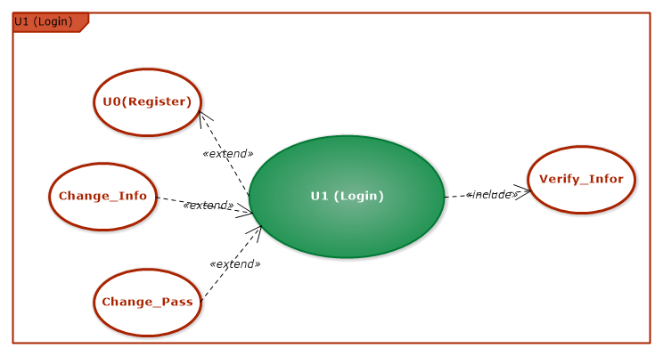

→ Usecase Login muon thuc hien duoc phai thuc hien xong use case Register va usecase Verify_Infor

2.

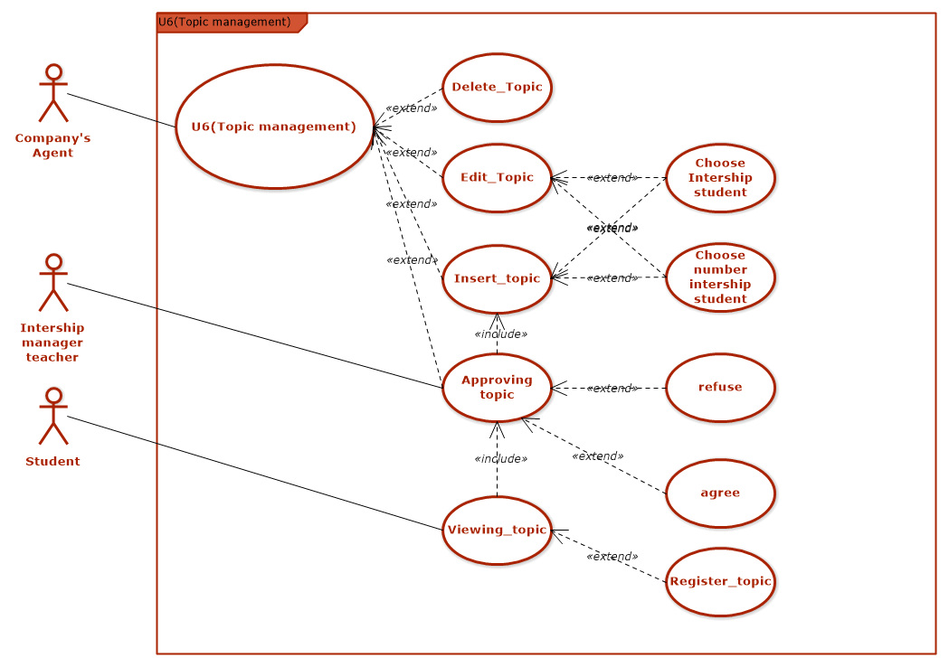

→ Usecase Approving topic thuc hien khi use case Insert_topic da thuc hien.

→ Sinh vien chi co the truy cap Usecase Viewing-topic khi Usecase Approving topic thuc hien xong.

3.

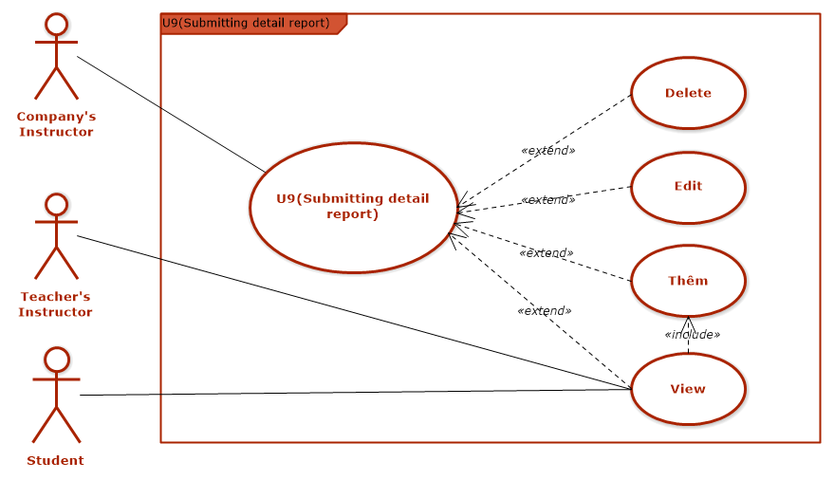

→ Teacher’s Instructor va Student chi co the View khi UseCase Them da thuc hien.

4.

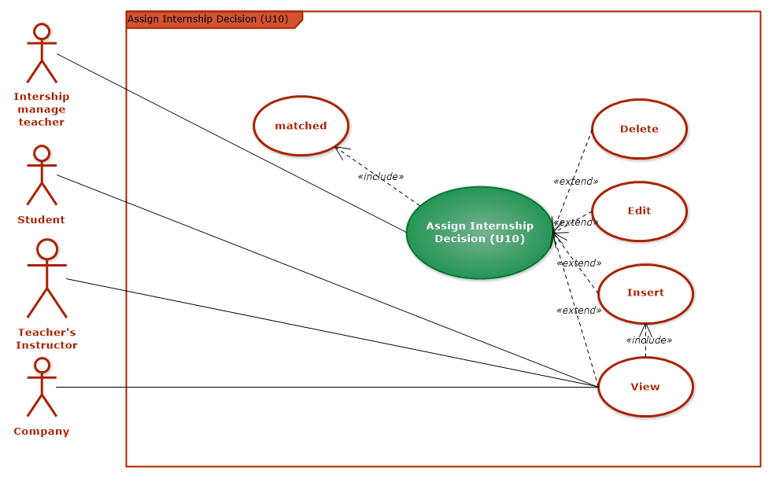

→ Teacher’s Instructor, Company va Student chi co the View (Assign Intership Decision) khi Intership manage teacher thuc hien xong Usecase Insert .

5.

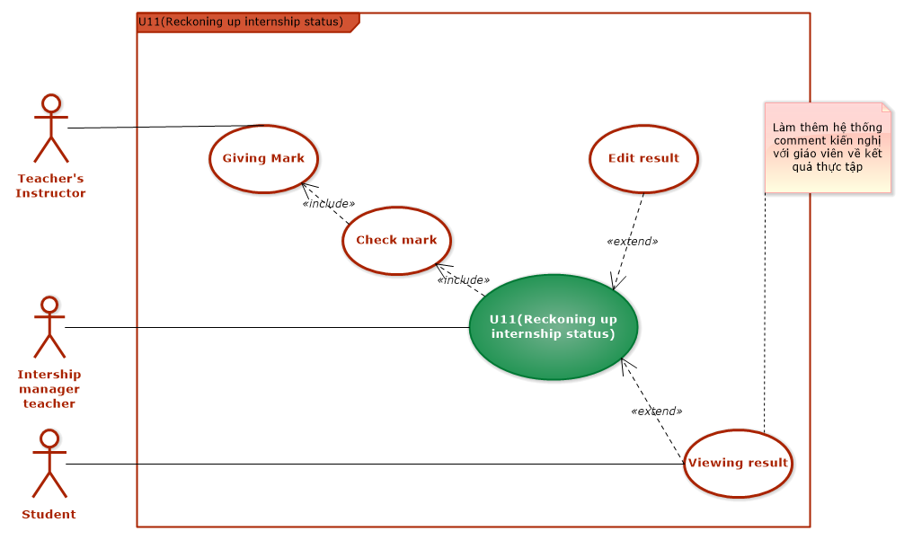

→ Intership manager teacher chi co the thuc hien Use Case Reckoning up intership status khi UseCase Check mark thuc hien xong. Va Check mark thuc hien khi Teacher’s Instructor da thuc hien Usecase Giving Mark.

6.

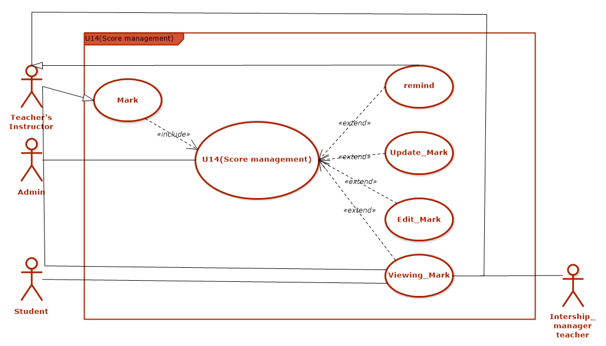

→ Usecase score management duoc thuc hien khi da thuc hien xong usecase Mark

7.

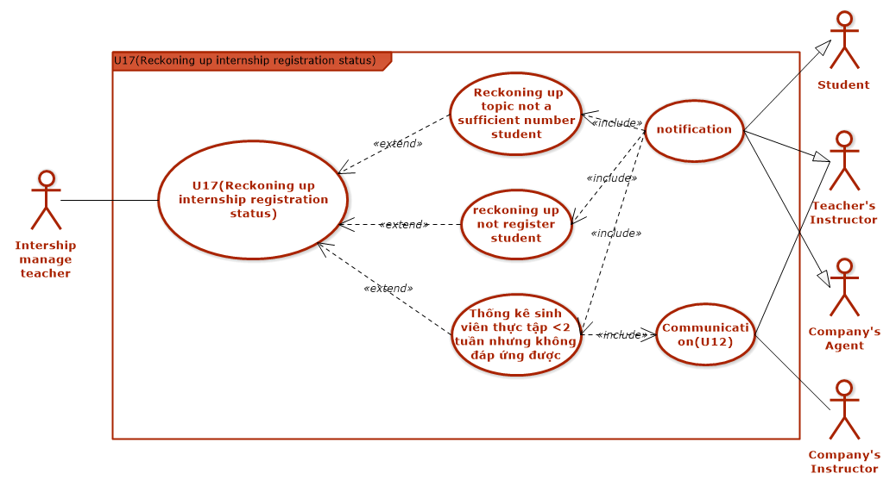

→ Use case Thong ke sinh vien thuc tap khong dap ung duoc yeu cau thuc tap thuc hien khi Usecase Trao doi duoc thuc hien.

→Use case Thong bao(notification) thuc hien khi Usecase Thongke da thuc hien.